Minutes
Bergan Catholic School Board of Directors Meeting

October 23, 2024 | 6:30 p.m. at Bergan Elementary Library

Meeting called to order by Chair Ryan Bojanski

In Attendance
Present: Ryan Bojanski, Todd Thomason, Elizabeth Borisow, Mandy Ostdiek, Dave Shrader, Dan Koenig and Rev. Walter Nolte
Absent: Tom Wolf, M.D., Terra Uhing
Guests in attendance: Doug Moore, Dr. Mary Ritzdorf

Approval of Minutes and Agenda
Minutes from the September Board of Directors Meeting and the Agenda for the October Board of Directors Meeting were approved and passed. Motion made by Dave Shrader and seconded by Mandy Ostdiek. All approved. Motion passed.

Public Input
None

Executive Session
None

Financial Report
None

Reports
School President Report: Dan Koenig
Human Resources Update
Resignations None
Appointments John Bergmanis, Custodial
Open Positions Elementary Kitchen Supervisor

Additional Volunteer or Work Grant Help Needed
1. Bus Drivers
2. Substitute Teachers
3. Varsity Basketball Game Operations (Shot Clock Operator)

Koenig provided a few school statistics:
- Bergan Catholic spends a very conservative $8,888 per student.
- Fremont Public School has an average cost per pupil of around $12,799
- If the 500 plus Bergan students multiplied by the average cost to educate a student in the Fremont Public Schools, it can be noted that by providing an education to our students at Bergan Catholic, we save the taxpayers of Fremont over $7.1 million dollars.
Scams
People are getting very brave lately when it comes to Scams. They have impersonated Dan Koenig, Rev. Walter Nolte and even our Board of Directors Chair Ryan Bojanski. Please follow this simple guide so that you do not get SCAMMED out of money…
- Always check the email or phone number that a request comes from… usually you will recognize that a number or email that is being used for a scam. An email should only come from our domains…. @berganknights.org or @stpatsfremont.org Always search the area code of a phone call or text message. Most should come from the 402 area code.
- It is ok to check with us verbally on any purchase that we ask you to make to verify the validity of that purchase. It is always better to be safe than sorry.
- If a leader or staff member needs money or funds from you, we will ask you in person. We will NEVER ask you to purchase gift cards and send them to us.
- After you get a scam, please block the person or number and delete the message. You can always do a screenshot of your phone or computer screen to keep a record that it happened.

Teacher Professional Development
Last week our Teaching Staff spent a considerable amount of time focusing on becoming better. We researched, discussed & collaborated on the topics of Professional Learning Teams, Educational Philosophy, Innovative Instruction, Student Centered Learning, Student Assessment scores, Teacher Instructional Rounds & Continuous School Improvement.

Parish Pastor/Campus Ministry Report: Rev. Walter Nolte
Father Nolte stated that the Awaken event set for January 29th will now move to January 30th.

Director of Operations Report: Nichole Owsley
Not present, Report Attached

Board Chair Report: Ryan Bojanski
Bojanski reported that the Board will move forward with reviewing financials for the date 30 days prior to the meeting. This is due to timing issues with reporting and when the Parish Finance Committee meets to review the financials. It will allow the Board to have a thorough review and oversight of the financials.

Finance Committee Report
Report attached

Discussion and Action Items
- Student Assessment Program Data – Doug Moore and Dr. Mary Ritzdorf
Dr. Ritzdorf reported that Bergan students completed testing for STAR and the scoring looked good! The staff reviewed the results on Friday, October 19th with Dr. Sara Hood from the Omaha Archdiocese. They now have the tools and a new approach to guide each of the students towards improvement based on each of their results. They are using the term “productive struggle” to help the students grow in knowledge and resilience.
Moore reported on the results of the ACT for Bergan students versus the state as well as other schools in the archdiocese. They are constantly looking for ways to improve the scores and help the students. He also mentioned that many colleges have removed the requirement to take the ACT, but that it is important to continue to encourage our students to take the ACT and work to score high on the test.

Closing
Closing prayer
Meeting adjourned at 7:40 p.m.
Next meeting November 20th at 6:30 p.m. at the Bergan Elementary School Library



Archbishop Bergan Catholic School exists to instill a passion, as exemplified by Christ, for faith, knowledge and service.

Archbishop Bergan Catholic School provides an exemplary Christ-centered education that develops the whole child through service, active learning and innovative instruction in order to achieve high expectations in a global community.

BERGAN CATHOLIC SCHOOL BOARD OF DIRECTORS MEETING AGENDA
WEDNESDAY OCTOBER 23, 2024 6:30PM
LIBRARY - BERGAN ELEMENTARY SCHOOL

- Call the Meeting to Order & Prayer

- Roll Call

- Consent Agenda
1. Approval of the meeting Agenda
2. Approval of the Minutes for the September meeting

- Public Input

- Executive Session

- Finance Reports (new Finance reporting structure discussed)

- Reports
1. School President
2. Pastor/ Director of Campus Ministry
3. Director of Operations
4. Board Chair
5. Finance Committee

- Action & Discussion Items
1. Student Assessment program data

- Closing Prayer & Adjourn


Board of Directors
President Report

Human Resources Update
Resignations 1. None
Appointments 1. John Bergmanis, Custodial
Open Positions 1. Elementary Kitchen Supervisor
Additional Volunteer or Work Grant Help Needed
1. Bus Drivers
2. Substitute Teachers
3. Varsity Basketball Game Operations (Shot Clock Operator)
School Statistics
-Bergan Catholic School has an average of 35 students per grade level with an average classroom size of 17 to 18 students.
-Bergan Catholic School has over 550 students enrolled in our education programs at Bergan Early Childhood Education Center, Bergan Elementary School & Bergan Middle/High School
-Bergan Early Childhood Education Center has over 40 students receiving Day Care Services daily along with 33 students in preschool classes.
-Bergan Elementary serves 286 students in grades PreK through 6.
-Bergan Middle/High School has 203 students enrolled in grade 7 through 12.
-There are a little over 75 staff members employed at Bergan Catholic. 28 of the staff members at Bergan Catholic have attended a Catholic School themselves. 18 of these staff members are Alumni of Bergan Catholic School.
-Bergan Catholic has an overall budget of $4.8 million dollars this year.
-Bergan Catholic spends a very conservative $8,888 per student.
-Fremont Public School has an average cost per pupil of around $12,799
-If the 500 plus Bergan students multiplied by the average cost to educate a student in the Fremont Public Schools, it can be noted that by providing an education to our students at Bergan Catholic, we save the taxpayers of Fremont over $7.1 million dollars.
SCAMS
People are getting very brave lately when it comes to Scams. They have impersonated Dan Koenig, Rev. Walter Nolte and even our Board of Directors Chair Ryan Bojanski. Please follow this simple guide so that you do not get SCAMMED out of money…
- Always check the email or phone number that a request comes from… usually you will recognize that a number or email that is being used for a scam. An email should only come from our domains…. @berganknights.org or @stpatsfremont.org Always search the area code of a phone call or text message. Most should come from the 402 area code.
- It is ok to check with us verbally on any purchase that we ask you to make to verify the validity of that purchase. It is always better to be safe than sorry.
- If a leader or staff member needs money or funds from you, we will ask you in person. We will NEVER ask you to purchase gift cards and send them to us.
- After you get a scam, please block the person or number and delete the message. You can always do a screenshot of your phone or computer screen to keep a record that it happened.
Teacher Professional Development
Last week our Teaching Staff spent a considerable amount of time focusing on becoming better. To do so we researched, discussed & collaborated on the topics of Professional Learning Teams, Educational Philosophy, Innovative Instruction, Student Centered Learning, Student Assessment scores, Teacher Instructional Rounds & Continuous School Improvement.

Respectfully,
Dan Koenig
President
Operations Overview:
Big Projects:
- The roof at MS/HS's THIS PROJECT IS Almost done!
- Waiting for Goldenrod to get back to us. We should have an owner rep decided by EOM, good
things here hopeful we will have good news to share very soon
- Grant applications are due in by EOY; we are working on an LOI for Campaign, and DHHS right
now to determine any large federal grants
- Big move for the team to be in the same office at the MS/HS everyone will be in new office space
on October 1st.
- Title Funding clean up and requisition completion
- Knight Event Committees are continuing to meet and we are almost sold out for the event :)

Admissions:
- I have 18 families in the funnel, including 4 families with at least one child already at
the school who want to transfer their other kids but can’t afford it. We're focusing on
making our efforts bilingual and collaborating with Jose to engage the
- Spanish-speaking community.
- The Knight Event is ramping up so I am busy with Qtego and uploading items.
- Bee club at the elementary school on Tuesdays & Thursdays after school.
- Stem Club at the high school after school.
- Getting into the classroom more with STEM.

Alumni Strategy/Bergan Fund
- Alumni Engagement: Monthly Alumni Newsletter emailed to all, mailed to 50s, 60s, & 70s,
letters to respective classes when a classmate passes away, Re-engage Alumni board and help
establish a distinguished alumni award and help update alumni contact information, monthly
alumni spotlights on social media and in the newsletter starting November
- Bergan Fund: the Bergan Fund ‘kick-off’ mailer is going out October 31st, connecting with
alumni with high propensity to give monthly, written thank yous to donors as they give, will
establish a list of those who gave last calendar year 4th quarter who have not gave yet and
connect with them in December
- Parish: St Patrick Annual Appeal - approximately a quarter of the way to goal, written thank yous to SPAA donors, Stewardship Sunday weekly email, Re-engage the Order of the Golden
Shamrock & Codicil Club groups
- Knight Event: Underwriting, live auction donations, managing ticket sales, & seating

Business Partners & Community Relations
- From 2023-24 to 2024-25, so far we’ve added 13 new Business Partners, and 4 dropped.
Bringing our total to 42 businesses.
- Dollar-wise (other than the 4 that dropped) less than 5 other businesses did not increase
their giving. This was because of new offerings (Scoreboard), and an increase in Knight
Event Underwriting.
○ There were some long-time business partners where we had to “shift” some dollars
from one line item to another within their Business Partnership to earn their
business.
■ Examples would be businesses like RVR Bank. In the past our Business
Partnership was $14,500/yr. This year they only gave us $12,500, because
they also gave us $25,000 for the scoreboard. This negatively impacted the
Bergan Fund by $2,500 because we pulled some of that money to make sure
they were still able to pay for a VIP Table at the Knight Event. All-in-all the
total we shifted was less than $15,000, and that came from other areas as
well, not just the Bergan Fund. (ie: STRIV downgrades, etc.)
- Because of the Scoreboard, we have 7 new business partners that we didn’t work with
before.
- Businesses have asked about a waiting list to get on the scoreboard. More people have also
asked about static signage as well. We will need to talk about signage prices (floor logos, etc)
in general as I think we are due for some price increases.

Marketing and Communications Update:
● Boosted Posts for Admissions
○ We’re focusing on reaching North Bend kids given their current situations, so we’ll
target them in our next boosted post. We also have a testimonial from a new family
in the North Bend area that is thriving, which we’ll feature.
● Knight Event
○ Getting all the items photographed and put into Qtego.
○ Trying to get items on the Knight Event that are new and exciting.
○ Sending out communications on all of the upcoming things that go with the Knight
Event.
○ Creating videos that will be played at the Knight Event. (Welcome, Fund a Need,
Thank you)

Maintenance Priority Projects
● MS/HS Roof
● Buildings Ready for Winter
● Hiring cleaning in-house to save quite a bit of money

IT Priority Projects
● Firewalls
○ In progress at HS; wrapping up configuration, EM will follow and both will have to
go in at the same time.
● Network Upgrades at School/ECEC
○ HS is 100% complete from a hardware perspective (sans firewall), EM will be
next, ECEC pending. More work to be done configuration-wise (VLANS) but
deferring that phase until firewalls are in.
● Ticket System
○ Have a server in place running iTop. (https://support.berganknights.net) Working
out a couple of issues in setup how tickets are grouped/viewable between
maintenance and IT and site branding.
● Cloud Proposal for office
○ The proposal is to move files currently located on the server in the basement to
the cloud (SharePoint) to remove that dependency on the server and the need for
a VPN at the office.
○ Replace desktops with laptops/docking stations for those that VPN to the office
and remote desktops to their desktops when needing to work from home.
○ Migrate the active directory function to the cloud that is currently provided by the
server.
○ Requested bid from Five-Nines to see what they would charge to migrate data to
sharepoint and set up AD in the cloud. Their bid was $22K. Will work on doing
this internally.

● Wireless AirFiber between HS and ECEC building
○ Need to reach out to Curtis at GP to kick off.
● BYOD Chromebooks
○ They are in, I need to get them labeled, onboarded, documented and
distributed.


Bergan Catholic School Board of Directors
Committee Meeting Report

Committee: Finance
Meeting date/time: Wednesday, October 16, 2024 6:30pm
Attendance: Tom Wolf (Chair), Ryan Bojanski, Mandy Ostdiek, Gavin Guldenpfennig (Staff Rep), Dan Koenig, Nichole Owsley

Agenda Items:
- Large Item Expenditures
Roof Update- Company was supposed to come today. The Stonebrook company did not show up. Kevin, one of their workers, did show up to meet with Nichole Owsley & John Faulkner. There still is work to be completed. We will not pay until all items are taken care of. We are disappointed to say the least.
- Gavin Guldenpfennig Staff Survey Follow up (25 responses to 2 questions)
Appropriate mark for the staff to identify what the difference between public school salary and Bergan salary would be. 75% goal was the minimum answer. Some would like to be within $2500 of the base pay. They would like us to be between 85% or 90% of what Fremont Public would make. There were a lot of ideas from staff members.. Possibly post the teacher salary pay scale in the parish bulletin.
- Teacher Pay Scale Categories
It would be nice to add more columns and add more years to the bottom of the columns as years of service, but we are not in a financial position to be able to do this right now. The best way to impact the greatest number of staff members is to adjust the starting salary.
- 2025-2026 Salaries & Benefits
Nichole has created a salary pay scale chart with a 3.5% increase.
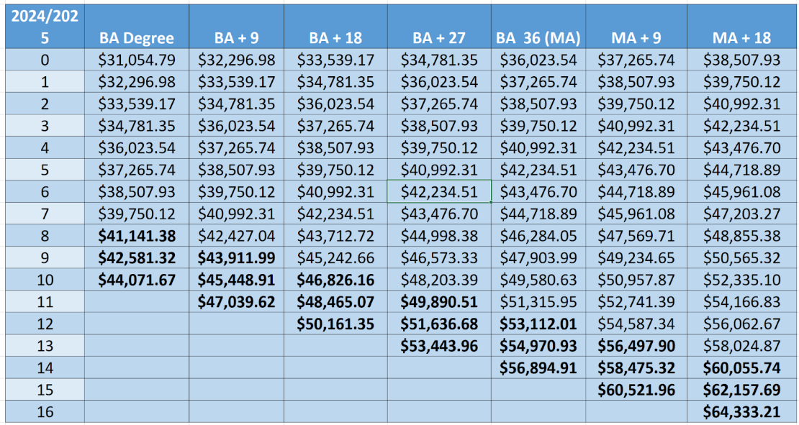
BOLD CATEGORIES CURRENTLY DO NOT EXIST , JUST A VISUAL AS AN EXAMPLE

Ryan created a system for using a measurable rubric for deciding what increases we take into consideration for salary and tuition increases.
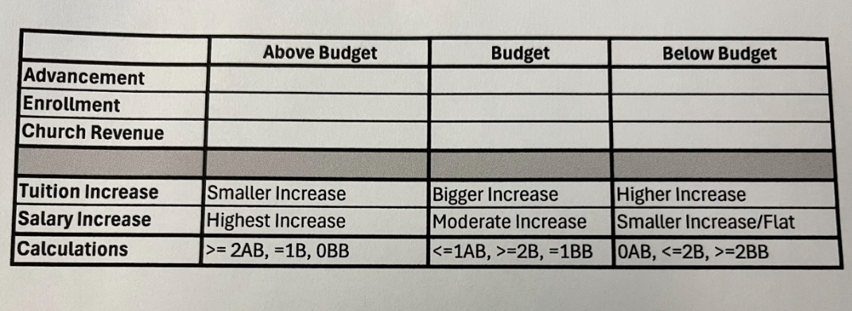
Idea to let fundraising take place and have Tuition Levels decided by January 1st, 2025.

***Additional Staff members to consider when we set increases for compensation…
School Employees
-Maintenance excluding Faulkner
-All ECEC staff
-Marketing & Admissions
-Lunch Program
-Support staff at the School (Secretary, Paras, etc.)

Church Employees
-Parish Office staff
-Director of Operations
-Senior/ Development officers (2)
-Director of Finance
-Network Administrator

Keep in mind all staff members received the 2023 Christmas bonus.

CREATE A SYSTEM IN ORDER TO BE SURE THAT INCREASES ARE EQUITABLE ACROSS POSITIONS WITHIN THE SCHOOL SYSTEM

WHO IS ULTIMATELY RESPONSIBLE FOR DECIDING THE INCREASES FOR THE SUPPORT POSITIONS WITHIN THE SCHOOL?

Do we make increases based on longevity? After 1 year or service and on their anniversary of service?

The bucket…. The budgeted increases for different positions. The Finance Committee does not set the Budget so how can they help decide which positions get increases?

Most increases last year were performance increases.

The Plan- The Board of Directors Finance Committee gives Dan K & Nichole O. a percentage increase for all Support Staff. Dan & Nichole need to complete annual reviews and give staff members a performance bonus dividing up the bucket created by the percentage increase to the staff.

Based on the numbers… the Board would like to be realistic and try to get to 75% of what Fremont Public School will pay its teachers for the 2025-2026 school year.

- 2025-2026 Tuition
Nichole provided a table with 3%, 4%, & 5% tuition increases. Keep in mind the board already approved Preschool MWF & Preschool TTH tuition numbers in September.
This committee agrees that we will do either a 3%, 4% or 5% increase on tuition for next year. No one wants to increase more than 5% as the top high school tuition dollar will stay under the $7,000 mark by being at $6,930.
This group would like to lean towards a 5% increase based on the financial situation that we are projected to be in. Ryan Bojanski looks at the rubric to help gauge what type of increase to consider.
EVERY 1% that we increase brings in an additional $26,400
Ryan would like Nichole to add columns for 6% and 7% for future projections.

- OPPORTUNITY SCHOLARSHIP
Keep in mind the opportunity scholarship options that may come to fruition. Bergan staff is waiting on the results of the election to find out if this initiative will have any longevity or will simply fold based on voters. Funders have to have their funds donated by Monday October 21, 2024. Students have to fit the requirements. This will be in place for sure for one year… next year is up to voters.

- Service Requirement
Mandy is hearing push back from a few families that are upset about the $250 fee on their tuition for not meeting their service requirement.

- Plan for Financial reports moving into the future
Based on reconciling accounts and reporting to the Parish Finance Committee, the Financials are going to be reported 60 days in the past…. The Board would essentially approve the August reports at the October meeting instead. She will bring big ticket items and the Board will attempt to operate 60 days in the past. If Nichole is not at the meeting, Dan & Tom will have a report that will be able to share the financial information. Operations Director will be sure that this information is communicated. Summary can be sent before to be sure the Board has time to look over the information and ask questions. October meeting will not include up to date financial information as the financials were already approved at the September meeting.

Unfinished business:
A. 2025-2026 Tuition Rates Committee decision by November & bring to the Board of Directors to approve by the December meeting to be ready by Jan 1, 2025 5% increase
B. 2025-2026 Staff Compensation decision does not need to be made by the committee by December and approved by the Board of Directors at the January meeting to be ready by February 1, 2025. 2%, 3% or 4% increase using the Rubric from Ryan Bojanski
C. Substitute Teacher pay increase
New business:
- Opportunity Scholarship plan based on election
Future action steps:
- Next meeting for Finance Committee tentatively plan for Wednesday December 11 at 6:30pm location TBD

