Minutes
Bergan Catholic School Board of Directors Meeting

December 18, 2024 | 6:30 p.m. at Bergan Elementary Library

Meeting called to order by Chair Ryan Bojanski

In Attendance
Present: Ryan Bojanski, Todd Thomason, Elizabeth Borisow, Tom Wolf, Dan Koenig and Rev. Walter Nolte
Absent: Mandy Ostdiek, Dave Shrader, Terra Uhing
Guests in attendance: Dr. Mary Ritzdorf and Chris Rainforth

Approval of Minutes and Agenda
Minutes from the November Board of Directors Meeting and the Agenda for the December Board of Directors Meeting were approved and passed. Motion made by Tom Wolf, M.D. and seconded by Todd Thomason. All approved. Motion passed.

Public Input
None

Executive Session
None

Financial Report
October YTD financials were provided through email to the Board of Directors two weeks prior to the meeting. There were no questions prior to the meeting or at the meeting about the financials. Ryan Bojanski requested that the P&L be included with the financials on the Board Google Drive as well. Motion made to approve the October 24/25 YTD Financials was made by Tom Wolf, M.D. and seconded by Elizabeth Borisow. All approved. Motion passed.

Reports
School President Report: Dan Koenig
Human Resources Update
Resignations 1. None
Appointments 1. None
Open Positions 1. Elementary Kitchen Supervisor

Additional Volunteer or Work Grant Help Needed
1. Bus Drivers
2. Substitute Teachers

National Catholic Schools Week
National Catholic Schools week is just around the corner. This special week will take place from Sunday, January 26 through Saturday, February 1, 2025. Each year we fill this week with fun events, dress up days and celebrations to help our kids be excited about attending a Catholic School and celebrate all things Bergan Catholic.

Nebraska Department of Education Rule 10 Compliance Visit
The Nebraska Department of Education will be visiting Bergan Catholic School on Wednesday February 12, 2025 for a Rule 10 Compliance Visit. The Nebraska Department of Education will be looking to be sure that we are in compliance with a variety of areas ranging from the master schedule to school policies.

Administrator Teaching Roles for 2nd Semester
In the second semester of the 2024-2025 school year, Mr. Koenig, Mr. Rainforth and Mr. Moore will continue to teach courses at the high school level. In addition, Mr. Koenig and Mr. Moore will facilitate Senior English during 1st & 5th period with instructional & curriculum assistance from Mrs. Dieckmann & Mrs. Guldenpfennig.

Dr. Mary Ritzdorf provided an update that the Elementary Parent Knights purchased new iPads for kindergarten to second grade which will help with Walk to Reading and other areas as we begin the second semester. She was very grateful for their generosity.

School Admin Representative – Chris Rainforth
Mr. Rainforth stated that it was a busy time of year as Bergan wraps up the 1st semester and going strong in the winter activities. There will be a mandatory moratorium from December 22-26 which means there will be no practice or interschool competition during this time. Bergan recently purchased a minibus for the ECEC. This will provide a much needed second bus as they transport students to and from the ECEC to the elementary school throughout the day.

Parish Pastor/Campus Ministry Report: Rev. Walter Nolte
Father Nolte stated their second 24:15 took place on the 1st Wednesday of December. It was well received by the Confirmation students, and they enjoyed hearing the stories shared by the older students. Father plans to meet 1 on 1 with every single student in the second semester to ask how the ministry team can help meet their needs.
Todd Thomason provided a brief update on a few of the outreach items they are working on to involve families from Bergan and other areas to volunteer at the church. They have asked Bergan families to volunteer at the Christmas Eve mass by welcoming families and helping with the mass.

Director of Operations Report: Nichole Owsley
Owsley stated that they are working on spending the COPS grant. We are the only district in NE to receive this grant which will help with glass coverings at the elementary where the windows are not bulletproof, purchasing bleed kits and panic buttons. In addition, all the doors at the MS/HS will be controlled access. They are working on getting vendors in to complete these projects. Owsley also stated that the Knight Event went well, and the final numbers will be available at the January Board meeting. See report for further updates for the Operations team.

Board Chair Report: Ryan Bojanski
Bojanski stated that the Board’s strategic plan is on the website and available for public view. We are still looking to expand the Board, and he will work on meeting with potential candidates after January. Bojanski asked the Board to send individuals that have interest to him in the next couple of weeks.

Finance Committee Update: Tom Wolf, M.D.
The Finance Committee met several times to discuss tuition and staff compensation for the 2025-2026 school year. Dr. Wolf presented the information to the Board and the proposed updates to tuition and compensation. Report is attached and items are listed in the action items below.

Discussion and Action Items
- Tuition Rates for 2025-2026 School Year
- Motion made to approve the 2025-2026 tuition amounts by grade level as presented in the PowerPoint, Elizabeth Borisow
- Seconded, Tom Wolfe, M.D.
- All approved
- Motion passed

- Staff Compensation for Contracted Staff
- Motion made to approve a 3% salary increase to contracted staff for the 2025-2026 school year, Tom Wolf, M.D.
- Seconded, Todd Thomason
- All approved
- Motion passed

- Staff Compensation for Non-Contracted staff for the 2025-2026 School Year
- Motion made to provide an increase for non-contracted staff of no more than a $26,516, including Early Childhood, Operations, Maintenance and Lunch Staff, for the 2025-2026 school year. Raises made on performance determined by Leadership, Tom Wolf, M.D.
- Seconded, Todd Thomason
- All approved
- Motion passed

- Compensation for Substitute Teachers
- Motion made to increase pay for substitute teachers from $100 per day to $125 per day, Tom Wolf, M.D.
- Seconded, Ryan Bojanski
- All approved
- Motion passed

- Approval of 2025-2026 School Calendar
The calendar was presented to the Board at the November Board meeting and the Board was asked to review prior to the December Board meeting.
- Motion made to approve the 2025-2026 School Calendar, Elizabeth Borisow
- Seconded, Todd Thomason
- All approved
- Motion passed

- Catholic Schools Week Knights of the Roundtable
Koenig shared that he has received seven nominations for the Knights of the Roundtable and asked the Board to send additional nominations his way.

- School Uniform options with Dennis Uniform closing
Bergan is looking for a new vendor to replace Dennis Uniform since they have closed. Elizabeth Borisow will lead a group of 3-4 individuals to select a new vendor and will provide an update at the January meeting.

Closing
Closing prayer
Meeting adjourned at 7:59 p.m.
Next meeting January 22nd at 6:30 p.m. at the Bergan Elementary School Library


Archbishop Bergan Catholic School exists to instill a passion, as exemplified by Christ, for faith, knowledge and service.

Archbishop Bergan Catholic School provides an exemplary Christ-centered education that develops the whole child through service, active learning and innovative instruction in order to achieve high expectations in a global community.

BERGAN CATHOLIC SCHOOL BOARD OF DIRECTORS MEETING AGENDA
WEDNESDAY DECEMBER 18, 2024 6:30PM
LIBRARY - BERGAN ELEMENTARY SCHOOL

- Call the Meeting to Order & Prayer

- Roll Call

- Consent Agenda
1. Approval of the meeting Agenda
2. Approval of the Minutes for the November meeting

- Public Input
- Executive Session

- Finance Reports

- Reports
1. School President- Chris Rainforth Admin representative
2. Pastor/ Director of Campus Ministry
3. Director of Operations
4. Board Chair
5. Finance Committee Update

- Action & Discussion Items
1. Tuition Rates for 2025-2026 School Year
2. Staff Compensation for 2025-2026 School Year
3. Approval of 2025-2026 School Calendar
4. Catholic Schools Week Knights of the Roundtable
5. School Uniform options with Dennis Uniform closing

- Closing Prayer & Adjourn

Next steps: January Board Meeting Topics-
-Admissions Plan & Dates
-Catholic Schools Week
-President Review
***Reminder to be sure that Board Committees are meeting quarterly
12/18/2024
Board of Directors
President Report

Human Resources Update
Resignations 1. None
Appointments 1. None
Open Positions 1. Elementary Kitchen Supervisor
Additional Volunteer or Work Grant Help Needed
1. Bus Drivers
2. Substitute Teachers
National Catholic Schools Week
National Catholic Schools week is just around the corner. This special week is celebrated at the end of January each year and will take place this year from Sunday January 26 through Saturday February 1, 2025. Each year we fill this week with fun events, dress up days and celebrations to help our kids be excited about attending a Catholic School and celebrate all things Bergan Catholic. This year we will have to do some creative scheduling as we have confirmed the scheduling of the Raptor United States Air Force Band on Friday January 31st. This means we will sponsor our own coffee event as the Chamber can not host for us on this day. We will put out a full schedule of events for CSW as we return to school for the second semester.

Nebraska Department of Education Rule 10 Compliance Visit
The Nebraska Department of Education will be visiting Bergan Catholic School on Wednesday February 12, 2025 for a Rule 10 Compliance Visit. The Nebraska Department of Education will be looking to be sure that we are in compliance with the following items…
1. Copies of each teacher’s weekly schedule and master schedule of all courses offered in the Middle/ High School.
2. A list of all staff members including principal, guidance counselor, and media specialist
3. Your school calendar for the 2024-2025 school year
4. Copies of the following school policies
003.05 -- Graduation Requirements in Policy or Handbook
004.01A-B -- Curriculum/Instructional Program
004.02B -- Kindergarten Admissions
004.02C -- K-6 Athletic Limitations
005.01A-D -- Assessment Plan
005.05 -- Student Assistance Process
007.06A -- Certificated Staff Evaluation Approval
010.01B -- Policy for Performance Reports
012.01B -- Policy on Instructional Hours

Administrator Teaching Roles for 2nd Semester
In the second semester of the 2024-2025 school year, Mr. Koenig, Mr. Rainforth & Mr. Moore will continue to teach courses at the high school level. Mr. Koenig will go from teaching 1st & 2nd Period World History to teaching the same course during 7th & 8th Period. Mr. Rainforth will move from teaching Theology 12 during 7th period to teaching it during 6th period. Mr. Moore will move from teaching American Government during 4th period & World History during 5th period to just teaching Government during 3rd period. Mr. Koenig and Mr. Moore will facilitate Senior English during 1st & 5th period with instructional & curriculum assistance from Mrs. Dieckmann & Mrs. Guldenpfennig.

Respectfully,
Dan Koenig
President

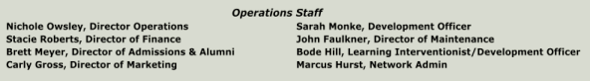
Operations Overview:
Big Projects:
The roof at MS/HS's THIS PROJECT IS Almost done!
Started multiple calls and meetings with Rainwood to focus on each step of the Campaign Spending the COPS grant
Securing Title Funding and ensuring we have a plan
Recap Knight Event and get all expenses in so we can see the final numbers
HR/Accounts Receivable PT to start this month
Admissions
● Unfortunately, I got behind on the Spanish recruitment and that is now the center of my
attention. Currently working on marketing materials and continuous improvements to the
website.
● Heading into the semester break, there will be a renewed effort on mid-term transfers. At
this point I only have one confirmed transfer at semester and one addition in Pre K.
● Dan and I are looking at the winter blitz of open houses and re-enrollment. This will be our second year of being 100% online for re-enrollment. The good news is that it is ready to go
for 2025.
● Growth - I continue to look for opportunities for growth in recruitment, outreach and
retention. This will be of particular importance for me going into the second semester.
● Evaluation - along with growth I’m constantly evaluating what I’m doing and ways I can
improve. Data collection continues to be my shortfall. On a positive note, the newly
admitted student form was well received.
● 24:15 continues to gain traction. With just two now completed, the interest in participation
from our current students continues to grow. This is a great opportunity to engage current
students and community members in a fun praise and worship experience. Our goal is to build a relationship with Christ.
Alumni Strategy/Bergan Fund
● Alumni Engagement: Monthly Alumni Newsletter emailed to all, mailed to 50s, 60s, & 70s, letters to respective classes when a classmate passes away, Re-engage Alumni board and help establish a distinguished alumni award and help update alumni contact information, monthly alumni spotlights on social media and in the newsletter starting December, monthly
connects with alumni with high propensity to give
● Bergan Fund: the Bergan Fund ‘kick-off’ mailer went out the week of Nov 25, written thank yous to donors as they give, will establish a list of those who gave last calendar year's 4th quarter who have not given yet and connect with them in December, putting together a ‘12 Days of Christmas Giving’ campaign to encourage giving prior to year end - including a postcard to 50s, 60s, & 70s
● Parish: St Patrick Annual Appeal - written thank yous to SPAA donors, Stewardship Sunday weekly email, Re-engage the Order of the Golden Shamrock & Codicil Club groups, Calendar Raffle selling underway
● Knight Event: Thank yous written
Business Partners & Community Relations
● Touching base with all business partners before year-end. Thanking them for a great 2024, and keeping the door open for conversations in 2025.
● Mailing out THANK YOU’S to all Knight Event Underwriters
● Making sure all winning bidders get connected with their items (or people who donated their items).
● Making sure reservations are made for those non-tangible items (front row at mass, etc.)
Marketing and Communications Update:
● Getting more footage of classroom stuff now that Knight Event is over.
● Boosting content for a Bergan Fund push and Admissions push.
● Making content for open houses and re-enrollment.
Maintenance Priority Projects
● Finishing MS/HS Roof
● Training Custodial Help
● Christmas Break Projects for Elementary/High School
● Water damage at the Church, paint/drywall
IT Priority Projects
● Firewalls
○ Both firewalls are configured and the VPN configuration is complete. Certificates will be added to the group policy, Google, and individual devices (Apple), and
installation will be slated over Christmas break.
● Network Upgrades at School/ECEC
○ HS is 100% complete from a hardware perspective (sans firewall). EM is 100% complete from a hardware perspective and new fiber runs (sans firewall). ECEC Flynn building has the switches upgraded. Still need to pull fiber and install
hardware in the ECEC main area and upgrade access points.
● Ticket System
○ Have a server in place running iTop. (https://support.berganknights.net). Not ready for primetime yet. Might be seeking another package as configuration and testing is not panning out in the way that I was wanting.
● Cloud Proposal for office
○ The proposal is to move files currently located on the server in the basement to the cloud (SharePoint) to remove that dependency on the server and the need for a VPN at the office. Working on a plan of attack for this. Slating this to be done over Christmas break.
○ Replace desktops with laptops/docking stations for those that VPN to the office and remote desktops to their desktops when needing to work from home.
Laptops and docking stations have been procured. Working with individuals to start migrating their data over. One down and three to go. Slated for January
post-Christmas season.
● Wireless AirFiber between HS and ECEC building
○ Need to reach out to Curtis at GP to kick off.

GUIDELINES FOR ARCHBISHOP BERGAN CATHOLIC SCHOOL HONORARY KNIGHTS OF THE ROUND TABLE

In order to honor those people who have shown outstanding dedication to the continuation of Catholic education at Archbishop Bergan Catholic School, we established the Knights of the Round Table and the Honorary Bergan Knight Awards.

These awards will be given annually during Catholic Schools Week. The Honorary Bergan Knight can be selected from past and present members of the Knights of the Round Table.

These selections are based on the following criteria:
1. Nominee supports the philosophy, goals, and objectives of Archbishop Bergan Catholic School.

2. Nominee may be (has been) a professional employee or volunteer, or a non-professional employee or volunteer, or a significant contributor to the educational mission of Archbishop Bergan Catholic School.

3 Nominee must give (has given) evidence of superior talent, skill, or competency which contributes (has contributed) in an outstanding way to the quality of educational opportunity at Archbishop Bergan Catholic School.

4. Nominee has rendered service to Catholic education such as:
a. Committee Work
b. Volunteer
c. Support Organizations
d. Substantial Financial Support
e. Outstanding Employee Service

NOMINATION PROCEDURE
All nominations must be submitted to the Principal of Archbishop Bergan Catholic. Nominations will be accepted from anyone. Nominations will be called for through the St. Patrick’s Parish Bulletin. Organizations (Faculty/Staff, Bergan Board of Education, Parish Council) will be solicited for nominations.
Deadline for nominations will be the Monday in January before Catholic Schools Week.

Previous recipients are listed below:
KNIGHTS OF THE ROUND TABLE:
* Denotes Knight of the Year
1986 - Mary Mahlberg*
1987 - Mae Morrissey *
1987 - Loretta Vance
1987 - Gerhold Concrete Products
1987 - Lorraine Kallhoff
1988 - Gary Schmidt*
1988 - Don Emanuel
1988 - Margaret (Muzzy) Barton

1989 - Neil Feser * 1995
1989 - Richard Vance
1989 - John Tharp
1989 - Jan Ortmeier*
1990 - Joe Vojtech*
1990 - Leona Kasel
1990 - Sandra Wiebold
1990 - Dorothy Cajka
1991 - Tom Stover
1991 - Sr. Elizabeth Ruskamp* 1994
1991 - Fr. Charles Swanson*
1991 - Joe Cajka
1991 - Jerry Mahlberg
1991 - Robert Vance, Sr.
1992 - Pete Dahlhauser * 1993
1992 - Harvey Hunke*
1992 - Rita Stieren
1992 - Bob Warner
1992 - Joe Wojtkiewicz
1993 - Walter Day
1993 - Richard Foxhoven 1999*
1993 - John E. Gibney
1993 - Carol Slupe
1993 - Dianne Vyhlidal
1994 - Sr. Elizabeth Ruskamp*
1994 - Steve Kneifl
1994 - Patricia Kassmeier
1994 - Robert Hegemann
1994 - Betty Feldhaus 2000*
1994 - Renee Bittner
1995 - Kitty Micek
1995 - Elaine Moore
1995 - Paige Beard
1995 - Walt Shacklett
1995 - Jay Berry
1995 - Lawrence & Etta Emanuel
1995 - JoAnn Kassmeier
1996 - Randy Eikmeier*
1996 - John Blide
1996 - Dan Mueller
1996 - Marilyn Austin
1996 - Juanita Henderson
1996 - Mary Baum
1997 - Don Evert*
1997 - Bob Brown
1997 - Renee Brown
1997 - Ranae Rogers
1997 - Fr. Frank Lordemann
1997 - Marie Peatrowsky
1997 - Sue Wewel
1998 - Msgr. John Flynn*
1998 - Kory Miller
1998 - Deanne Wieneke & Gene Wieneke
1998 - Paul Meister & Lee Meister
1998 - Jim Feldhaus
1998 - Marilyn Olson
1998 - Vic Henry
1999 - Amy Brandert
1999 - Lloyd Brooks
1999 - Larry Kreikemeier
1999 - Shirley Kreikemeier
1999 - Rob Kreikemeier
1999 - Marci McElroy
1999 - Jean Muller
1999 - Judy Nelson
1999 - Carol Schmidt
2000 – Charlie & Mary Lou Diers
2000 - Betty Feldhaus*
2000 - Nancy Knoell
2000 - Joanne Leriger
2000 - Steve Narans
2000 - Jacqueline Roumph
2000 - Darlene Saeger
2000 – Gene & Peg Steffensmeier
2000 - Cindy Uhlik
2001 - Diane Vyhlidal*
2001 - Jeanne Boesch
2001 - Michelle Emanuel
2001 - Mike Emanuel
2001 - Nick Herrman
2001 - Fr. Owen Korte
2001 - Kathy Molle
2001 - Julie O’Hanlon
2001 - Sherry Thompson
2001 - Toni Vering
2001 - Sue Wilcynski
2002 - Judi Boggy
2002 - Amy Brandert
2002 - Mary Coday
2002 - Tom Coday
2002 - Jerry Delaney
2002 - Allan Kassmeier
2002 - Steve Kneifl*
2002 - Helen Krause
2002 - Larry Moore
2002 - Jeff Rump
2002 - Debbie Rump
2003 - Brad Anderson & Sue Anderson
2003 - Tom Brown*
2003 - Tom Kimminau
2003 - Lisa Leatherbury
2003 - Jan Stieren
2004 - Dan Boesch
2004 - Katherine Griffen*
2004 - Doreen Kaspar
2004 - Diana Meiergerd
2004 - Brad Porter & Mary Porter
2004 - Andree Towey & Don Towey
2005 - Ron Beacom
2005 - Kate Hurst & Marcus Hurst
2005 - Beth Johns & Jeff Johns
2005 - Allan Kassmeier*
2005 - Diane Swanson & Scott Swanson
2005 - Jim Wewel & Jodi Wewel
2005 - Dan Wiesen & Kathy Wiesen
2006 – Dottie Anderson
2006 – Jeanne Boesch*
2006 – Monte Brown & Jenise Brown
2006 – Roger Goree & Rita Goree
2006 – Micky Jacobs
2006 – Sue Kassmeier
2006 – Roger Ortmeier
2006 – Lynnette Sellon
2006 – Jeff Wilmes & Beth Wilmes
2007 – Brad Anderson*
2007 – Rick Leonard
2007 – Gary & Sandy Liekhus
2007 – Todd & Judy Miles
2007 – Shannon Morrissey
2007 – Chris Rainforth
2007 – Chris & Lynne Walz
2008 – Ruth & Marlin Binnebose
2008 – Karie & Lyle Boggs
2008 – Duane Johnson
2008 – Knights of Columbus
2008 – Melinda Madsen
2008 – James Meiergerd
2008 – Chris Paulson
2008 – Lynnette Sellon*
2009 – Julie Diers
2009 – Jeff Engel
2009 – Mary Glowacki
2009 – Elaine Moore*
2009 – Jane Rasmussen
2009 – Les & Koni Shallberg
2009 – Matt & Julie Sleister
2009 – Pat Wendt
2010 – Tim Burger
2010 – Ronda Burger
2010 – Bill Ekeler
2010 – Heather Ekeler
2010 – Terry Kempf
2010 – Fr. Owen Korte*
2010 – Jan Leslie
2010 – Kim Mruz
2010 – Scott Painter
2011 – Kurt Bottorff
2011 – Christy Conrad
2011 – Mike & Kim Dieckmann
2011 – Mary Beth Hilbers
2011 – Micky Jacobs*
2011 – Joe Uhlik
2014 – Fr. Dave Belt*
2014 – Ryan Bojanski
2014 – Sue Engel
2014 – T. J. Folkers
2014 – Jeremy Karmann
2014 – Fr. James Keiter*
2014 – Phil Lutz
2014 – Don Ortmeier
2014 – Kerri Pentel
2014 – Bill Vobejda
2014 – Joan Vobejda
2015 – Larry & Pat Fisher
2015 – Karl Fryklind
2015 – Dave Mendlik
2015 – Joan Tainter
2015 – Dennis & Jacque Witthuhn
2015 – Joe Wojtkiewicz*
2016 – MaryLynne Bolden
2016 – John Prauner
2016 – Curtis Marolf
2016 – Lori McIntyre
2016 – Tabitha Sheets
2016 – Wendy Kerkaert
2016 – Marcus & Kate Hurst*
2017 – Becky Dahlhauser
2017 – Angie Kempf
2017 – Terry Kempf
2017 – Chris Janke
2017 – Kris Janke
2017 – Jessica Koenig
2017 – Seth Mruz
2017 – Shalynn O’Neill
2017 – Kristi Sendgraff
2017 – Paul Sendgraff
2017 – Charlie & Mary Lou Diers*
2018 – Steve Gossett
2018 – Jill Gossett
2018 – Gene Kassmeier
2018 – Misti Wolf
2018 – Jeremy Murman
2018 – Matt Mueller
2018 – Therese Hoyle
2018 – Bonnie Nebuda
2018 – Les & Koni Shallberg*
2019 – Karl Fryklind
2019 – Andrea Ridder
2019 – Rich Roeder
2019 – Wyatt Morse
2019 – Dave & Mary Shrader
2019 – Jeff & Beth Wilmes*
2020 – Tad Dinkins
2020 – Chris Kabes
2020 – Karen Kortan
2020 – Jennifer Powers
2020 – Rich Ray
2020 – Lyle & Karie Boggs*
2021 – Brock Rogers
2021 – Deb Kingston
2021 – Pat Brannen
2021 – Fr. Walter Nolte
2021 – Doug Moore
2021 – Jim & Kim Peitzmeier
2021 – Papa Trucking & Grading
2021 – Knights of Columbus #1497*
2022 – Nate Pribnow
2022 – Brenda Kohl
2022 – Dan & Cheryl Koenig
2022 – Nichole Owsley
2022 – Cindy Nielsen
2022 – Terry & Janice Nosal
2022 – Jake Herre
2022 – Lynn Dinkins
2022 – Chris Rainforth*
2023 – Katie & Phinehas, Comfort Dogs
2023 – Dawn Gilfry
2023 – Brett Meyer
2023 – Carly Gross
2023 – Jan Boyer
2023 – Toni Dean
2023 – Patti Bowman
2023 – Mark & Mary Ann Snelson
2023 – Ryan Mlnarik
2023 – Pat Brannen*
2024 – Sarah Kellogg
2024 – Mandy Ostdiek
2024 – John Faulkner
2024 – Ken Mace
2024 – Amy Cone
2024 – Christina Pieper
2024 – Katie Nielsen
2024- Tom Wolf
2024 – Deanna Rogers
2024 – Judy Miles*


Bergan Catholic School Board of Directors
Committee Meeting Report

Committee: Finance
Meeting date/time: Wednesday, December 11, 2024 6:30pm
Attendance: Tom Wolf (Chair), Ryan Bojanski, Mandy Ostdiek, Gavin Guldenpfennig (Staff Rep), Dan Koenig, Nichole Owsley

Agenda Items:
- Review October Financial Report
Summary & communication process is working well now that we have updated the process. Knight Event was adequate in the area of fundraising. It was not as fruitful as last year, which was a record year. There was a $500,000 Budget which we fell short of. Nichole anticipates being $100,000 under budget. Still waiting on some expenses to come through and be reimbursed. Income from Knight Event just shy of $400,000? Bergan Fund is still low, but there is a plan to address the current shortfall. More checks are coming in. Tom asked about alumni being challenged to be able to raise more for the Bergan Fund. There was a class challenge for the Scoreboard but it did not do well. Nichole states that our donor base responds well to matches rather than class challenges. Idea of sponsoring a student as a challenge to donors? Big Give will take place in May and will boost the total.
- Review Agenda Items & Unfinished Business from October Meeting
- 2025-2026 Salaries & Benefits
Nichole has created a salary pay scale chart with a 3.5% increase.
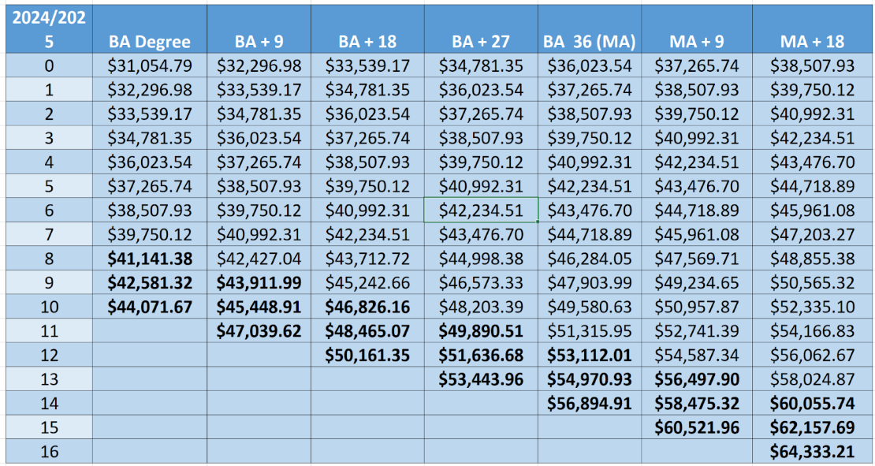
BOLD CATEGORIES CURRENTLY DO NOT EXIST , JUST A VISUAL AS AN EXAMPLE
Considerations- -3.5% Increase on scale …. also create a 4% increase scale
-2 less contract days
-Longevity Bonus - every 5 years get a monetary bonus that begins at $1000 and increases $500 each 5 years
-Less time in Professional development meetings ½ time?
-Consider adding one more level to the bottom of the pay scale
-no additional hires other than replacing teaching positions

- 2025-2026 Tuition
Trinity Tuition rates
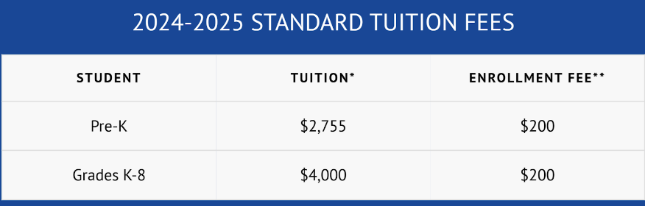

BERGAN CATHOLIC 2024-2025 Tuition Rates
Grades | Annual Cost | 12 monthly payments
9th - 12th Grade | $6,600 | $550 per month
7th - 8th Grade | $5,750 | $480 per month
5th - 6th Grade | $5,200 | $434 per month
Kindergarten - 4th Grade | $4,500 | $375 per month
Pre-Kindergarten | $2,625 | $219 per month
Preschool Mon/Wed/Fri | $1,375 | $115 per month
Preschool Tue/Thur | $1,150 | $96 per month
5% Increase

BERGAN CATHOLIC 2025-2026 Tuition Rates
Grades | Annual Cost | 12 monthly payments
9th - 12th Grade | $6,925 | $577 per month
7th - 8th Grade | $6,025 | $502 per month
5th - 6th Grade | $5,450 | $454 per month
Kindergarten - 4th Grade | $4,725 | $394 per month
Pre-Kindergarten | $2,750 | $230 per month
Preschool Mon/Wed/Fri | $1,440 | $160 per month
Preschool Tue/Thur | $1,260 | $140 per month
Ryan Bojanski looks at the rubric to help gauge what type of increase to consider.
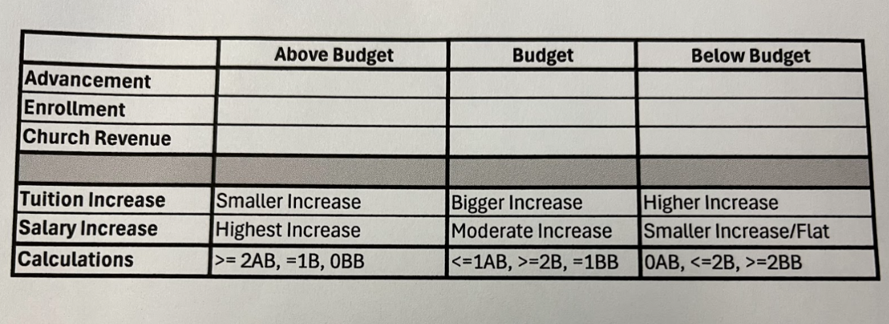
Advancement- Below Budget
Enrollment- At Budget
Church Revenue- Above Budget = We fall right in the middle for projections.
Tuition Increase = Bigger Increase
Salary Increase = Moderate Increase

EVERY 1% that we increase brings in an additional $26,400

- FAMILY ENROLLMENT FEE
Keep Enrollment Fee at $200. Communicate that we are not raising the fee.
If families have a problem paying their enrollment fee, talk to Stacie or Nichole to roll it into your monthly payment plan.

- 2025-2026 SUBSTITUTE RATES
Currently $100 a day. This falls way short. Increase to $125. Evaluate this each year.

- Opportunity Scholarship based on Election results
Up to $30,000 to spend and we will promote to our families during reenrollment.
This all goes through OSN. Focus on new families first to gain enrollment.

Unfinished business: email from Nichole & Dan and taking an email vote
Approval of recommendations for the Board of Directors
Bring recommendations to the Parish Finance Committee to approve
New business:
Future action steps:
- Next meeting for Finance Committee tentatively plan for 4th quarter to discuss administration increases. Be sure to look over Guidance Counselor and ECEC Director Compensation packages.
- Nichole & Dan will put together ideas and send 3.5% 4% Staff Increases
Longevity Bonus
1 Year added to the pay scale
Financial impact of going from $100 to $125 on substitute pay.

